

Specification

for

Application Security and Delegation

Shekhar Vaidya

10/8/07



Proprietary and Confidential to BBS Technologies, Inc.

© 2006 BBS Technologies, Inc.; all rights reserved.

Revision history:
When? | Who? | What?
10/8/07 | Shekhar | Created.
10/30/07 | Shekhar | Functional design completed.

Table of Contents
1. Revision history: ii
2. Table of Contents iii
3. Requirements 1
3.1. Overview/Purpose 1
3.1.1. Related Customer Requests 1
3.2. Target Users 1
3.3. Feature/Function Market Requirements 1
3.3.1. Required Functions 1
3.3.2. Non-Supported Functions 5
3.4. FAQ 5
3.5. Open Issues 5
3.5.1. Create SQL Server Login for User 5
4. Functional Design 6
4.1. User Interfaces 6
4.1.1. Navigation Pane 6
4.1.2. Application Security View 6
4.1.3. Enabling/Disabling Application Security 7
4.1.4. Add Permission 7
4.1.5. Delete Permission 11
4.1.6. Edit Permission 11
4.2. Installation and Upgrade 12
4.3. Permissions and other Required Configuration 12
4.4. Licensing Issues 12
4.5. Dependencies 12
4.5.1. Dependencies on Idera Software 12
4.5.2. Third-Party Software Required on the Customer Machine 12
4.5.3. Third-Party Software Required Internally 12
5. Internal Design 12
5.1. Architecture 12
5.2. Installation Issues 12
5.3. Schedule 13
5.3.1. Work Breakdown and Sizings 13
5.3.2. Areas of Risk 13
6. Quality Assurance Considerations 13
6.1.1. Overview 13
6.1.2. Developer-Created Unit Tests 14
7. Documentation Considerations 14
8. Bibliography 14

Requirements

Overview/Purpose
From 5.1 POR:
- Customers have DBAs that manage specific servers and they want to be able to limit the servers they can see to only the ones they manage.
- Customers also have different types of users (DBAs, Operators, Help Desk Users, etc) and they want to limit access to certain functionality
- I want to get rid of the Web Console and can’t until I have a read-only solution.
- This question is often raised during evaluation

Related Customer Requests
- Role based application security and alerting
  - PR 208849 – Visa Singapore
  - PR 204313 – Customer unknown
  - PR 204339 – NORC
- Tracking mechanism for response to alert item
  - PR 209553 – Citigroup
- Track user changes to SQLdm application settings
  - PR 209578 – AZ Dept of Economic Security

Target Users
This feature is targeted towards uber DBAs who want to delegate which SQL Servers junior DBAs can access using SQLdm. And, be able to limit the SQLdm functionality that junior DBAs can access.

Feature/Function Market Requirements

Required Functions

Application Security
The three elements of application security are users, target objects, and powers. The user is assigned powers over target objects. These elements are defined below:

User
The user in SQLdm is defined by the Windows User account or the SQL Login used to connect to the SQLdm Repository.

Target Object
The target objects are the SQL Servers monitored by SQLdm. The user can be assigned one or more monitored SQL Servers. When a monitored SQL Server is assigned to a user, the user has access to all its components like databases, services, resources, etc.
Note that not all powers require target objects to be specified. For example, the Administrator power implies access to all monitored SQL Servers and SQLdm itself. See the next section for more details on this power.

Power
The customer can assign Administrator, Read-Only or Full-Access powers to a user. The Read-Only or Full-Access powers are granted over one or more monitored SQL Servers. The Administrator power does not require any monitored SQL Servers, it applies to that installation of SQLdm.
The three powers control access to the different types of tasks. The types of tasks are:
- View monitored SQL Server data.
- Modify monitored SQL Servers – properties, alert configurations, SQL Server configurations, maintenance mode, etc.
- Modify SQLdm configuration – add/remove monitored SQL Servers, license management, delegation, etc.
The powers are described below:
- View – The user can view all data collected for the assigned monitored SQL Servers. The user cannot modify monitored SQL Servers or modify SQLdm configuration.
- Modify – The user can view all data collected and modify assigned monitored SQL Servers. The user cannot modify SQLdm configuration.
- Administrator – the user can view all data and modify any monitored SQL Servers. The user can also modify SQLdm configuration.

Default Application Security Status (Out-of-the-box and Upgrade)
By default application security in SQLdm is disabled. When a customer first installs or upgrades to SQLdm 5.1+, application security is disabled and all SQLdm users have full access.

Sysadmin Application Security Rule
When SQLdm application security is enabled, all users that belong to the sysadmin server role on the Repository SQL Server are Administrators in SQLdm. This rule cannot be deleted or edited by the customer.
The sysadmin rule provides a safety net, in case the application security is not configured correctly. It provides a way for the customer to connect to SQLdm and correct the issue.

Configuring Application Security

Enabling application security
Only users who are sysadmins on SQLdm Repository can enable application security. When application security is enabled, the sysadmin rule will be created automatically (see 3.3.1.1.5).

Disabling application security
Only users who are SQLdm Administrators can disable application security. When the application security is disabled all the security rules will be deleted..

Add Permission
The user can assign View, Modify or Administrator permission to a user specified by Windows user account or SQL Login. The user can associate monitored SQL Servers with View or Modify permissions.
If the specified Windows user account or SQL Login does not have a SQL Server login, then one is created. If the SQL Server login is not a database user in the SQLdm database, then the login is added as a database user. If the Administrator permission is specified, then the database user is added to the dbowner role in the SQLdm database.

Delete Permission
All the permission rules, excepting for the default application security rule can be deleted. When a rule is deleted, and it’s the last reference to the user then the associated database user is deleted. Note that the SQL Server login is not deleted, this has to be cleaned up manually by the customer.

Edit Permission
The user can edit an existing permission rule. Any field in the permission rule excepting the user can be modified. The user cannot be changed. The user can edit the following:
- Enable/disable the rule
- Change permission – when the permission is changed from View/Modify to Administrator then the associated SQL Servers are removed.
- Assign/Remove SQL Servers

Additive Permission
It will be possible to create multiple rules that involve the same SQL Server with different permissions. When multiple permissions are involved, the user will effectively get the highest permission.
For example,
- If a user A is assigned View and Modify over Sever X by two different rule, then the effective permission that the user has is Modify over Server X.
- If a user A has been assigned View over Server X and Administrator by two different rules, then the effective permission that the user has is Administrator.

SQLdm UI

View only assigned monitored SQL Servers
Only those servers that have been assigned to the user can be viewed in the desktop client. This applies to the following places in the UI:
- Tree view.
- Active Alerts on the Today Page
- List of SQL Servers shown when copying alert configuration
- List of SQL Servers shown in Report filters
- Alerts Pane
  - Only alerts for assigned servers are visible in the alert view.
  - Server filters
- Only ToDo items for assigned servers are visible in the ToDo view.
- Servers listed in Manage Servers
- List of Servers in Notification Rules and Providers

Limit UI functionality based on assigned powers

View
The user with View power can only view the data collected for the associated SQL Servers. This user cannot do the following:
- Cannot access Administration Pane
- Cannot configure alerts
- Cannot access Notifications
- Cannot access ToDo (or just can’t change the status?)
- Cannot access Manage Servers
- Cannot put a server in maintenance mode
- Cannot access Tools > Grooming
- Cannot edit the settings/properties of a Managed Server (change collection interval, connection credentials, enabling Query Monitor, changing Query Monitor settings, or changing Table Statistics collection configuration)
- Overview > Configuration > Edit Value … each details pane offers the ability to change a SQL Server setting
- Cannot Kill Session
- Clear the Procedure Cache
- Update Statistics
- Rebuild Indexes
- Start and Stop services
- Start and stop jobs (once this is added back in, of course)
- Cycle Server Log
- Configure SQL Server Logs
- Import data.
- Manage licenses
- Default alert configuration

Modify
The user with Modify power can view collected data and act on assigned SQL Servers. This user cannot do the following:
- Add servers for monitoring.
- Access administration tab.
- Manage licenses.
- Import data.
- Default alert configuration

Administrator
There is no restriction, the user with this power can do everything in SQLdm.

Non-Supported Functions

Users identified by groups and local accounts
Create permissions based on Windows groups or local accounts is not supported.

Granular Permissions
Permissions more granular then View, Modify and Administrator are not supported.

Granular Targets
Target objects more granular then monitored SQL Servers is not supported.

Allow any user to enable Application Security
Only user who belongs to the sysadmin server role on the Repository SQL Server can enable Application Security. Allowing any user to enable Application Security is not supported.

FAQ
This section should present a high level FAQ that is used to answer common questions from others as they read the spec and also that customers using the feature may ask. This should also provide a start for “He said, She said” documents for sales.

Open Issues

Create SQL Server Login for User
Should a SQL Server login be created for specified Windows user or SQL Login, if one does not already exist. This will require that the MS service account or SQL credentials used by MS will need to have privileges to create SQL Server logins.

Functional Design

User Interfaces

Navigation Pane
The SQLdm desktop client Outlook navigation pane will be extended to include a new group, Administration. This group will contain views for SQLdm administrative functions, for example Application Security, Custom Counters, etc. A screen shot of the Outlook navigation pane is show below.
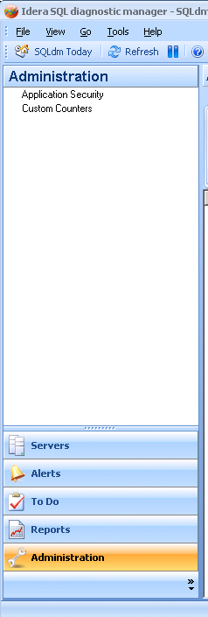

Application Security View
When the user clicks on the Application Security node in the navigation pane, the Application Security view is displayed in the main view area.
This view has a ribbon with one tab, called Configure. The Configure tab has buttons for: Add Permission, Delete Permission, Edit Permission, Enable Security, and Disable Security. More on the buttons in next few sections.
The grid view shows permissions, and has the following columns:
- Checkbox – enable/disable a permission
- User – name of the user
- Type – type of user (Windows or SQL Login)
- Permission – which permission
- SQL Servers – servers assigned to the user (will be empty for Administrator power)
- Comment – user entered comment
The grid supports the SQLdm standard functionality – sort, group, print, and export. The context menu for the grid supports Add Permission, Delete Permission, Edit Permission, and Enable/Disable Permission.
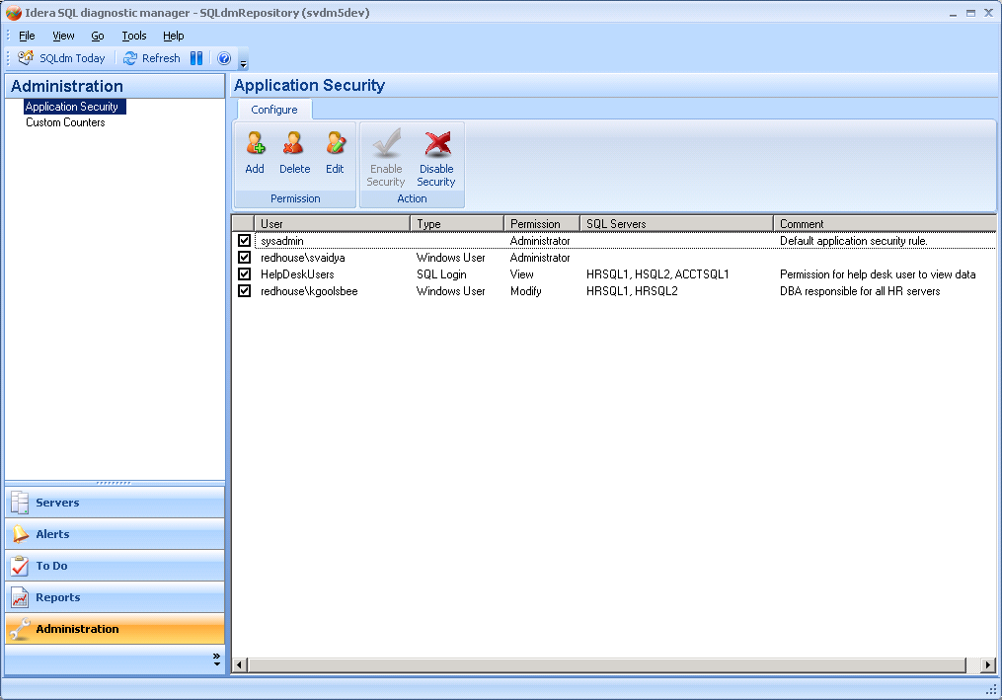

Enabling/Disabling Application Security
Out of the box, application security is disabled. Only users who belong to the sysadmin role on the Repository SQL Server can enable application security. When application security is disabled all the buttons will be also disabled. Excepting for the Enable Security button if the user belongs to sysadmin role.
The SQLdm application security can be disabled by users who are Administrators. There will be a confirmation box displayed asking them to confirm the action.

Add Permission
When the user has to click the Add Permission button it then launches the Add Permission Wizard. This wizard is used to add SQLdm permission.
The first screen of the wizard is the welcome page, as shown below.
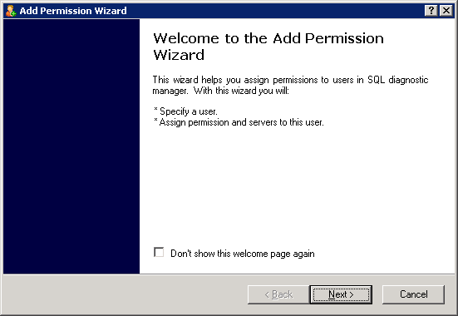

When user clicks Next the Select User page is displayed (as shown below).
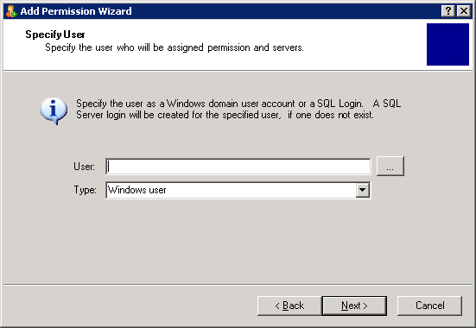
The user can enter Windows user name (domain\user format) or SQL Login name in the User text field. Or they can browse for a Windows user or SQL Login. When type is set to Windows user, the browse button will bring up the Active Directory object picker control for browsing Windows user accounts (shown below). Or if the type is SQL Login, they will see a dialog which lists the SQL Logins to select from.
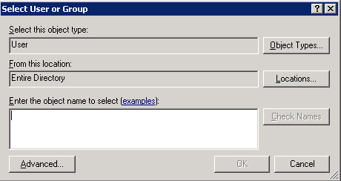
If the SQL Login specified does not exist on the Repository SQL Server, the user will be prompted for the password for the SQL Login that will be created (this wizard page is not shown).
The user goes to the Specify Permission page when Next is clicked on Specify User page.
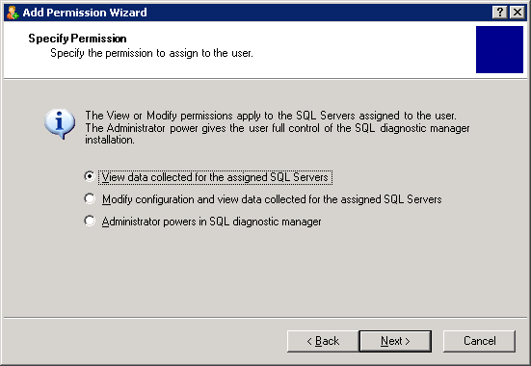
If the user has selected View or Modify permission, then they get to select SQL Servers. If Administrator power is selected they do not have to select SQL Servers.
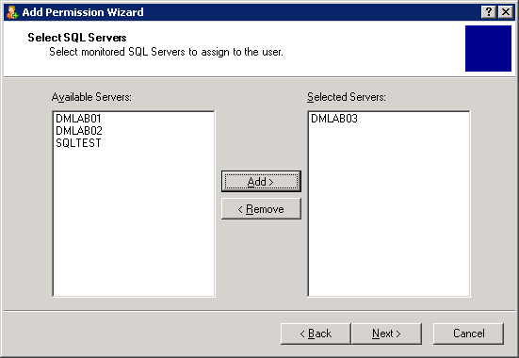
The user goes to the Finish page when Next is clicked on Select SQL Servers page.
The Finish page summarizes the permission being created by the user. The summary shows the user, permission and SQL Servers. When the user clicks Finish, the permission is saved in the Repository. Also if the SQL Login for the user does not exist, then its created.

Delete Permission
The user can delete the application security rule by selecting a row in the grid and clicking on the Delete button or choosing the Delete Permission context menu item. The user is prompted to confirm the deletion of the application security rule.

Edit Permission
The user can edit the assigned permissions by selecting a permission rule and clicking on the Edit button or choosing Edit Permission context menu item. The user edits the permission using the following dialog:
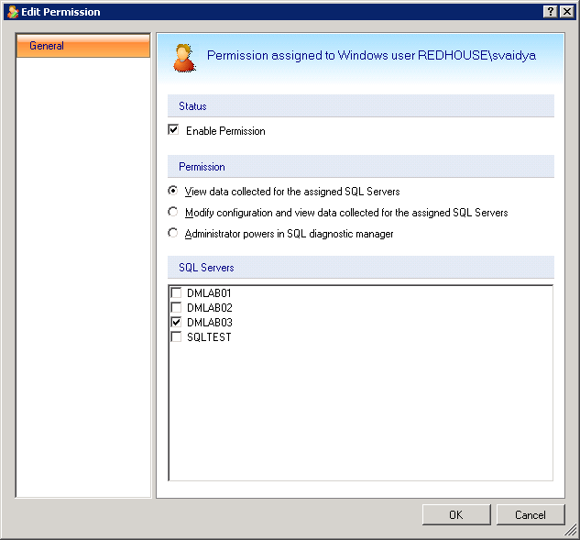

Installation and Upgrade
The upgrade will need to make modifications to the Repository schema.

Permissions and other Required Configuration
The credentials used by the Management Service to connect to the Repository needs to permission to:
- Create SQL Server login and database user for the user who is being granted permission.

Licensing Issues
N/A.

Dependencies

Dependencies on Idera Software
No new dependencies other then what is already required.

Third-Party Software Required on the Customer Machine
N/A.

Third-Party Software Required Internally
N/A.

Internal Design

Architecture
An overview of the architecture behind this feature – how it works, components, communication between components etc

Installation Issues
Insert changes for installation – new files to be dropped, new configuration screens etc. Think about the initial install and upgrade cases.

Schedule

Work Breakdown and Sizings
Insert areas that put the implementation or schedule at risk – Assumptions made in design, new areas that have a learning curve etc. Break the project into logical components and add time for design, coding, integration, unit testing. These estimates should not take into account outside forces like maintenance work. These will be applied in building the overall project schedule. A general rule of thumb is to break any unit of work greater then 1 week into smaller pieces to ensure accuracy and to allow measurement of progress during the project.
Component | Who | Sizing
R&D
Code Piece #1
Code Piece #2
Porting
Unit and Integration Testing
Total

Areas of Risk
There are many types of risks. For example, a section might describe
- Areas with big learning curve
- Design assumptions that still need to be proven
- a technical hurdle that needs to be overcome.
- An area which has many unknowns
- Outcomes of other plans/implementations which could affect the deliverability of this feature.
Where possible, each section should explain the risk, quantify the risk, enumerate possible actions to address the risk, and recommend the action that is appropriate.

Quality Assurance Considerations

Overview
Insert explanations for QA considerations that are not apparent from the rest of the specification. Include things like tests on platforms that you want run in greater width then a developer can easily do or which tests you would want as an acceptance test each time a release goes out the door.
This section should identify all the testing activity that should be performed to verify the project has:
- Satisfied the completion criteria
- Works consistently with the existing components or works at least as well as the component being replaced
- No other components have lost functionality or no longer work
- Meets the standards as defined and approved by this document
- Identifies all the edit rules for each data element in the process

Developer-Created Unit Tests
Automated, Developer-Created Unit Tests which will be Created (and Passed to QA)
Developer Tests which will be Manually Performed

Documentation Considerations

Bibliography

